Measuring Supply Chain Performance on Residential Construction

Faqih Ramadhan, Muhamad Rizki, Nazrudin Fadilah, Aryati Indah Kusumastuti
Universitas Swadaya Gunung Jati, Indonesia

Email: faqihr464@gmail.com, rizkimuhamad64875@gmail.com, nazarudin520@gmail.com, aryati.indah.kusumastuti@ugj.ac.id

Abstract
Supply chain management in residential construction projects requires a performance measurement system that supports effective evaluation, control, and decision-making. This study aims to analyze the effect of supply chain performance measurement on the performance of the housing development supply chain. The research was designed using an explanatory quantitative approach with a structured, questionnaire-based survey method. Data were collected cross-sectionally from 50 respondents who are the main actors in the housing supply chain, including project managers, contractors, subcontractors, procurement staff, and material suppliers. Supply chain performance measurement is operationalized through the dimensions of cost efficiency, timeliness, quality, flexibility, collaboration, risk management, and sustainability. Data were analyzed using descriptive statistics and linear regression analysis with the help of SPSS. The results show that supply chain performance measurement has a positive and significant effect on the performance of the housing development supply chain (β = 0.791; p < 0.001), with a coefficient of determination (R²) value of 0.651. These findings indicate that approximately 65.1% of the variations in housing supply chain performance can be explained by supply chain performance measurement. This research makes a theoretical contribution by positioning supply chain performance measurement as a strategic construct tested inferentially, rather than merely an evaluative tool. Practically, the results confirm the importance of implementing a structured supply chain performance measurement system to improve the operational performance of housing projects. All data presented are processed survey data, allowing replication and retesting in different research contexts.

Keywords: Supply Chain Performance Measurement; Supply Chain Performance; Residential Construction; Supply Chain Management; Quantitative Research.

INTRODUCTION
Supply Chain Management (SCM) is positioned as a strategic approach to maintain a balance between customer satisfaction and producer efficiency, which has direct implications for the cost efficiency and operational performance of an organization (Hayden et al., 2020). When supply chain performance is disrupted—for example, due to uncertainty regarding input availability or weak coordination between actors—organizational competitiveness and performance are also affected. Therefore, supply chain performance measurement is a managerial necessity for identifying performance gaps and formulating appropriate corrective measures (Aswat et al., 2023; Firdaus et al., 2023). The literature confirms that the supply chain is a system encompassing the flow of products, information, and finances; thus, supply chain performance represents the achievement of goals across supply chain members and can be analyzed through the effectiveness and efficiency of these flows (Aswat et al., 2023; Riantini et al., 2023).
In project contexts that rely heavily on the accuracy of meeting input requirements and cross-party coordination, the management and measurement of supply chain performance become increasingly critical. Performance measurement not only serves as an evaluation tool but also as a foundation for control and decision-making at strategic, tactical, and operational levels (Hayuningtyas et al., 2020; Mayangsari & Fauzi, 2023). Through a structured performance measurement system, organizations can enhance process efficiency, optimize workflows, and systematically identify opportunities for continuous improvement (Mañay et al., 2022; Mayangsari & Fauzi, 2023).
Supply chain performance measurement is regarded as a fundamental aspect because it supports continuous improvement and allows for holistic performance evaluation (Harya et al., 2020). However, its implementation faces practical challenges, particularly related to the complexity of supply chain systems and the numerous relevant performance dimensions, making the selection of appropriate performance measures far from simple (Harya et al., 2020; Sitorus et al., 2020). Various measurement frameworks have been developed, including the Supply Chain Operations Reference (SCOR), which provides end-to-end process descriptions and a set of standardized metrics to measure performance (Celina et al., 2022; Sitorus et al., 2020). In addition, Balanced Scorecards (BSCs) and Key Performance Indicators (KPIs) are widely used to complement process-based measurement with multidimensional perspectives and target-oriented evaluation (Mursidah & Fauzi, 2022; Shidiq et al., 2024).
This gap is particularly evident in the residential construction context, where empirical investigations into the strategic impact of performance measurement remain limited. The urgency of this research, therefore, lies in its potential to provide empirical evidence that can guide project stakeholders to move beyond perceiving performance measurement as merely an administrative requirement. By establishing a statistically significant relationship between measurement practices and improved supply chain outcomes, this study offers a compelling rationale for developers and contractors to systematically invest in and integrate these systems into their core project management processes. Such efforts are crucial for improving efficiency, reducing waste, and ensuring the timely and high-quality delivery of housing projects.
The novelty of this research is twofold. First, it reframes supply chain performance measurement from being a predominantly evaluative tool to a strategic construct whose influence can be empirically tested. Second, it applies this conceptualization within the underexplored context of residential construction, providing specific and actionable insights for practitioners in this sector. This study, therefore, seeks to address the identified gap by analyzing the effect of supply chain performance measurement on housing development supply chain performance using an inferential quantitative approach.
Nonetheless, the literature suggests that supply chain performance measurement has generally been positioned as an evaluative and diagnostic tool, rather than as a strategic construct empirically tested for its inferential influence on supply chain performance. These limitations are even more visible in residential construction, which is often characterized by vulnerability to delays, cost sensitivity, and issues of building quality and defects. Therefore, this study aims to analyze the effect of supply chain performance measurement on housing development supply chain performance using an inferential quantitative approach, thereby filling existing empirical gaps and providing both theoretical and practical implications for housing project management.

RESEARCH METHOD
Research Design and Approach
This study is designed as a quantitative research with an explanatory approach to test the relationship between variables through hypothesis testing and inferential statistical analysis. The explanatory approach is commonly used in quantitative survey research that aims to explore the relationships between constructs statistically, including relationships that are assumed to be causal according to the direction of the hypothesis formulated theoretically (Amani & Mfumbilwa, 2024; Kamani et al., 2023; Konalingam et al., 2024).
The data collection strategy used is a survey method with a structured questionnaire to obtain respondents' perception data related to the construct being studied. The survey method was chosen because it is effective in collecting quantitative data from respondents who have direct experience of the phenomenon being studied, and is commonly combined with descriptive and inferential statistical analysis in quantitative observational research designs (Amani & Mfumbilwa, 2024; Döring et al., 2022).
This research is cross-sectional, i.e. data is collected over a specific period of time (one-shot survey). The cross-sectional design is suitable for survey-based hypothesis testing and analysis of intervariable relationships in a single measurement (Amani & Mfumbilwa, 2024; Kamani et al., 2023). Nevertheless, it should be noted that cross-sectional design has limitations in generating strong causal inference because it does not observe changes between times and opens up the possibility of inverse causality or two-way relationships. Therefore, the interpretation of causal results in this study is carried out carefully as theoretical causality in the direction of the hypothesis, rather than a definitive experimental or longitudinal causality (Choudhury et al., 2024; Seixas & Macinko, 2020; Lingyan Wang et al., 2024).

Population and Research Sample
The research population includes the main actors in the housing development supply chain in Cirebon Regency, namely parties directly involved in the flow of products, information, and money in housing projects. This population selection is relevant because supply chain performance is determined by the performance of cross-members involved in the supply chain's end-to-end process (Aswat et al., 2023; Riantini et al., 2023). In addition, the SCOR framework models the supply chain through the plan–source–make–deliver–return process, so that the logical unit of analysis is the actor directly involved in the process (Sitorus et al., 2020).
The research sample consisted of 50 respondents representing key operational roles, including project managers, contractors, subcontractors, procurement staff, and material suppliers. The selection of respondents considers direct involvement and understanding of the project's supply chain processes, so that the measured perceptions reflect relevant empirical experience (Hafidz & Rahmawati, 2023; Kamani et al., 2023). The generalization of the results of the study is limited to the context of the research area and is interpreted according to the limitations of the cross-sectional design (Lingyan Wang et al., 2024).

Variable Research and Operationalization Instruments
The research instrument was in the form of a structured closed questionnaire with a five-point Likert scale, which was used to collect respondents' perception data in one measurement period. The questionnaire is designed to measure two main constructs, namely the measurement of supply chain performance and the performance of the supply chain of residential construction. The measurement dimension was developed based on the SCOR framework and enriched with collaboration, risk management, and sustainability perspectives. The dimensions used include cost efficiency, timeliness, quality, flexibility, collaboration between actors, risk management, and sustainability (Aswat et al., 2023; Mayangsari & Fauzi, 2023; Riantini et al., 2023).

Test of Instrument Validity and Reliability
The research instruments are tested to ensure validity and reliability according to quantitative research practices. Validity indicates the accuracy of the instrument in measuring the construct in question, while reliability reflects the internal consistency of the measurement (Thanasas et al., 2022; Li Wang, 2021). Reliability tests were performed using Cronbach's Alpha, and the high alpha values were interpreted as evidence of excellent internal consistency as well as the feasibility of the instrument for further analysis (Hong et al., 2021; K. Wang, 2023).

Data Analysis Techniques
Data was analyzed using Statistical Product and Service Solutions (SPSS). The analysis stages include descriptive analysis, validity and reliability tests, and linear regression analysis to test the hypothesis of the relationship between supply chain performance measurement and housing development supply chain performance. The use of linear regression is in line with the research practice of cross-sectional explanatory surveys which aim to objectively test the relationships between variables (Amani & Mfumbilwa, 2024; Döring et al., 2022).

RESULTS AND DISCUSSION
This section presents the results of quantitative data analysis obtained from 50 respondents who are the main actors in the housing development supply chain. The analysis was carried out using SPSS-based descriptive and inferential statistics, in line with the research practice of cross-sectional explanatory quantitative surveys (Amani & Mfumbilwa, 2024; Döring et al., 2022). The data presented is the data processed by the questionnaire, so that it allows replication and retesting using the same procedures and instruments.

Descriptive Statistics of Research Variables
The results of descriptive statistics show that the Supply Chain Performance Measurement has an average value of 1 with a standard deviation of 0.53, which is in the high category. This value indicates that respondents consider the practice of measuring supply chain performance in housing projects to have been applied relatively systematically. The low standard deviation reflects the uniformity of respondents' perceptions, which reinforces the stability of the perception data in the context of this study.

Table 1. Characteristics of Research Respondents
No. | Role of Respondents | Number (people) | Percentage (%)
1 | Project Manager | 10 | 20
2 | Main Contractors | 12 | 24
3 | Subcontractors | 9 | 18
4 | Procurement Staff | 8 | 16
5 | Material Suppliers | 11 | 22
Total |  | 50 | 100

Judging from the measurement dimensions, reliability and quality aspects, cost efficiency, and timeliness obtained relatively high scores, which shows that SCOR framework-based indicators have become a major focus in supply chain management practices. In addition, the dimensions of flexibility, collaboration, risk management, and sustainability also show high average values, indicating attention to adaptive and long-term aspects of the supply chain management of housing projects.

Table 2. Descriptive Statistics of Research Variables
No. | Variable / Dimension | Red | Standard Deviation | Categories
A | Supply Chain Performance Measurement (X) | 4,11 | 0,53 | Height
1 | Cost Efficiency | 4,12 | 0,55 | Height
2 | Responsiveness | 4,14 | 0,5 | Height
3 | Quality (Reliability-related outcomes) | 4,18 | 0,48 | Height
4 | Flexibility | 4,05 | 0,56 | Height
5 | Collaboration Between Actors | 4,1 | 0,52 | Height
6 | Risk Management | 4,08 | 0,54 | Height
7 | Sustainability | 4,02 | 0,57 | Height
B | Residential Supply Chain Performance (Y) | 4,14 | 0,51 | Height
8 | Material Needs Planning | 4,2 | 0,46 | Height
9 | Precision Material Procurement | 4,16 | 0,49 | Height
10 | Material Specification Conformity | 4,18 | 0,47 | Height
11 | Material Distribution Efficiency | 4,1 | 0,52 | Height
12 | Job Productivity | 4,05 | 0,55 | Height
13 | Quality of Construction Work | 4,12 | 0,5 | Height

Meanwhile, the Housing Development Supply Chain Performance showed an average value of 4.14 with a standard deviation of 0.51, which is also in the high category. The indicators of material need planning, procurement accuracy, and material specification suitability obtained relatively higher values than other indicators. These findings show that the performance of the supply chain that is felt operationally is well assessed by project actors, especially in aspects directly related to the smooth construction process.

Instrument Validity and Reliability Tests
The results of the validity test showed that all questionnaire items had correlation coefficients that met the validity criteria, so that they were declared able to measure the construct in question. Reliability tests using Cronbach's Alpha yielded a value of 0.963 for the supply chain performance measurement variable and 0.912 for the residential supply chain performance variable. The high alpha value indicates excellent internal consistency, in accordance with the practice of evaluating the reliability of instruments in quantitative survey research (Hong et al., 2021; K. Wang, 2023).

Table 3. Results of the Validity and Reliability Test of Research Instruments
No. | Variable | Number of Items | Item–Total Correlation Range | Cronbach's Alpha | Remarks
1 | Supply Chain Performance Measurement (X) | 40 | 0,421 – 0,812 | 0,963 | Highly Reliable
2 | Residential Supply Chain Performance (Y) | 6 | 0,538 – 0,796 | 0,912 | Highly Reliable

3.3 Inferential Analysis and Hypothesis Testing
Hypothesis testing was carried out using linear regression analysis to assess the relationship between supply chain performance measurement and supply chain performance of housing development. The results of the analysis showed that the measurement of supply chain performance had a positive and significant effect on the performance of the housing supply chain, with a regression coefficient of 0.791 and a significance level of p < 0.001. The value of the determination coefficient (R² = 0.651) indicates that approximately 65.1% variation in housing supply chain performance can be explained by supply chain performance measurements.

Table 4. Linear Regression Analysis Results
Yes | Independent Variables | Regression Coefficient (β) | t-count | Sig. (p-value)
1 | Supply Chain Performance Measurement (X) | 0,791 | 9,45 | 0

R | R Square (R²) | Adjusted R Square | F-count | Sig. F
0,807 | 0,651 | 0,644 | 89,3 | 0,000

These findings provide empirical evidence that a more mature and comprehensive performance measurement system is related to improving supply chain performance in residential projects. However, in keeping with the cross-sectional design character, this relationship is interpreted as an inferential association in the direction of the hypothesis, rather than a definitive evidence of experimental causality (Choudhury et al., 2024; Lingyan Wang et al., 2024).

Interpretation of Key Findings
The results of the study show that a higher rate of implementation of supply chain performance measurement is related to better supply chain performance of housing development. These findings support the view in the literature that performance measurement serves as an evaluation and control mechanism that allows organizations to identify performance gaps as well as formulate systematic improvement measures (Harya et al., 2020; Hayuningtyas et al., 2020). The measurement dimensions that include cost efficiency, timeliness, quality, flexibility, collaboration, risk management, and sustainability reflect a relatively holistic approach. This approach is in line with the SCOR framework which views supply chain performance as the result of end-to-end process integration and the effectiveness of product, information, and money flows (Celina et al., 2022; Sitorus et al., 2020).
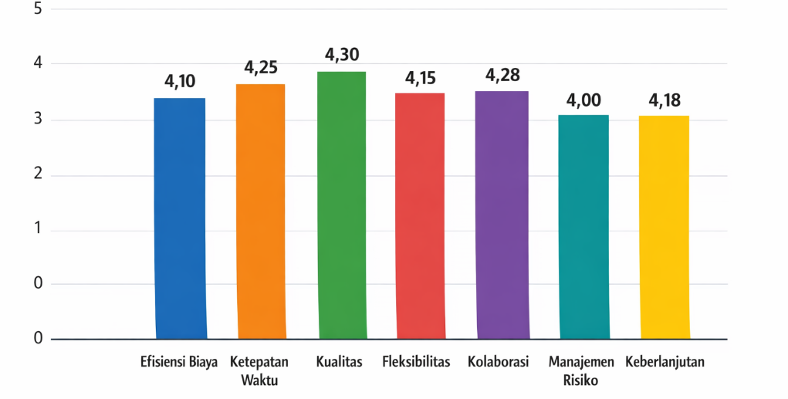
Figure 1. Average Supply Chain Performance Measurement Dimension Score.

Visualization of the average dimensional score (Figure 1) shows that the dimensions of timeliness and quality occupy a relatively high position, which indicates the attention of the project actors to the aspects of meeting schedules and the reliability of results. This underscores the relevance of SCOR attributes in capturing key issues of housing supply chain performance.

Performance Measurement as a Strategic Construct
In contrast to most previous studies that position supply chain performance measurement as a purely evaluative or diagnostic tool (Hafidz & Rahmawati, 2023; Stifany et al., 2020), the results of this study show that performance measurement can be treated as a strategic construct directly related to supply chain performance. The positive relationship between the performance measurement variables and supply chain performance, visualized through scatter plots and regression lines (Figure 2), reinforces the finding that the more systematic and comprehensive the measurements applied, the better the supply chain performance achieved.
Although the relationships tested are inferential and cross-sectional data-based, the direction of the relationship consistent with the theory supports the theoretical causality argument in the direction of the hypothesis (Amani & Mfumbilwa, 2024; Kamani et al., 2023).
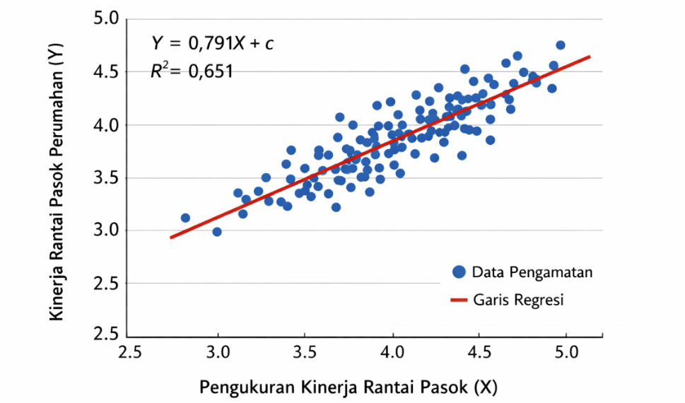
Figure 2. Scatter Plots X and Y Relationships with Regression Lines

Relevance to the Context of Housing Projects and Implications
The context of housing projects has distinctive characteristics, such as susceptibility to delays, material and labor cost sensitivity, and building quality and defect issues. The dimensions of timeliness, quality, and risk management and sustainability that obtained relatively high scores suggest that SCOR-based performance measurement is relevant to capture such complexity (Aswat et al., 2023; Riantini et al., 2023). Theoretically, this study strengthens the position of SCPM as a strategic variable in the study of construction supply chain management. In practical terms, these findings imply that housing developers and contractors need to integrate supply chain performance measurement systems in a structured manner to support data-driven decision-making and project performance improvement.

CONCLUSION
This study aims to analyze the effect of supply chain performance measurement on the performance of the housing development supply chain using an explanatory quantitative approach based on a cross-sectional survey. Based on the results of inferential statistical analysis, this study concludes that supply chain performance measurement has a positive and significant effect on housing supply chain performance. The positive and significant regression coefficient (β = 0.791; p < 0.001) indicates that improvements in the quality and implementation of the supply chain performance measurement system are associated with enhanced performance in housing development supply chains.
The coefficient of determination (R² = 0.651) shows that 65.1% of the variation in housing supply chain performance can be explained by supply chain performance measurement, while the remaining percentage is influenced by other factors outside the research model. These findings provide empirical evidence that performance measurement functions not only as an evaluative tool but also as a strategic construct directly influencing supply chain performance in housing projects.

REFERENCES
Amani, D., & Mfumbilwa, E. E. (2024). Destination Promotion Videos and Tourism Knowledge: A Road Toward Residents’ Empowerment in Emerging Tourism Destinations. Sage Open, 14(3). https://doi.org/10.1177/21582440241276182
Aswat, J., Maswadi, M., & Kusrini, N. (2023). Efficiency of Robusta Coffee Supply Chain Performance in Kubu Raya Regency, West Kalimantan Province. Jurnal Penelitian Pertanian Terapan, 23(4), 538–546. https://doi.org/10.25181/jppt.v23i4.2976
Celina, J. S., Kusumawardani, D. M., & Fathoni, M. Y. (2022). Evaluasi Kinerja Rantai Pasok Perpustakaan Institut Teknologi Telkom Purwokerto Menggunakan Supply Chain Operational Reference (SCOR) Model Berbasis Objective Matrix (OMAX). Jurikom (Jurnal Riset Komputer), 9(2), 296. https://doi.org/10.30865/jurikom.v9i2.4014
Choudhury, R., Park, J., Banarjee, C., Coca, M. G., Fukuda, D. H., Xie, R., Stout, J. R., & Thiamwong, L. (2024). Associations Between Monitor-Independent Movement Summary (MIMS) and Fall Risk Appraisal Combining Fear of Falling and Physiological Fall Risk in Community-Dwelling Older Adults. Frontiers in Aging, 5. https://doi.org/10.3389/fragi.2024.1284694
Döring, N., Conde, M., Brandenburg, K., Broll, W., Groß, H., Werner, S., & Raake, A. (2022). Can Communication Technologies Reduce Loneliness and Social Isolation in Older People? A Scoping Review of Reviews. International Journal of Environmental Research and Public Health, 19(18), 11310. https://doi.org/10.3390/ijerph191811310
Firdaus, R. O., Solihin, I., & Iskandar, B. H. (2023). Pengukuran Kinerja Rantai Pasok Cumi-Cumi Di Pt. Xyz PPN Muara Angke Menggunakan Metode Scor. Albacore Jurnal Penelitian Perikanan Laut, 7(3), 349–357. https://doi.org/10.29244/core.7.3.349-357
Hafidz, H., & Rahmawati, N. R. (2023). Pengukuran Kinerja Supply Chain Management Cv. Industri Classica Variasi Menggunakan Metode Scor. J. Manaj. Bisnis Dan Terap, 1(1), 64–74. https://doi.org/10.20961/meister.v1i1.455
Harya, G. I., Sudiyarto, S., & Santoso, W. (2020). Model Prioritas Untuk Kinerja Rantai Pasok Kakao Di Jawa Timur, Indonesia. Jurnal Ilmiah Sosio Agribis, 20(1). https://doi.org/10.30742/jisa2012020976
Hayuningtyas, M., Marimin, M., & Yuliasih, I. (2020). Peningkatan Kinerja, Mitigasi Risiko Dan Analisis Kelembagaan Pada Rantai Pasok Cabai Merah Di Kabupaten Garut. J.Tek.Ind.Pert., 22–35. https://doi.org/10.24961/j.tek.ind.pert.2020.30.1.22
Hong, X., Li, Y., Chen, Z., Lai, Y., Dai, Q., & Liang, W. H. (2021). Developing a Reliable and Valid Competency Model for Assistant Dentists in China. BMC Medical Education, 21(1). https://doi.org/10.1186/s12909-021-02986-0
Kamani, E., Kalisz, D., & Szyran-Resiak, A. (2023). Patients’ Behavioral Intentions Toward Robotic Adoption in Healthcare: An Approach on Apprehension of Embedding Robotics. Journal of General Management, 48(4), 370–385. https://doi.org/10.1177/03063070221080008
Konalingam, K., Thivaakaran, T., Kengatharan, N., Achchuthan, S., Hensman, G. H., & Harishangar, A. (2024). Exploring the Drivers of Pro-Environmental Behavioral Intentions in an Emerging Nation. Social Responsibility Journal, 20(9), 1697–1723. https://doi.org/10.1108/srj-09-2023-0517
Mañay, L. O. R., Guaita-Pradas, I., & Marques-Pérez, I. (2022). Measuring the Supply Chain Performance of the Floricultural Sector Using the SCOR Model and a Multicriteria Decision-Making Method. Horticulturae, 8(2), 168. https://doi.org/10.3390/horticulturae8020168
Mayangsari, A., & Fauzi, F. A. (2023). ANALISIS DESAIN METRIK PENGUKURAN KINERJA RANTAI PASOK TEBU (Kasus Di Pabrik Gula Wringin Anom Kabupaten Situbondo). Agribios, 21(1), 34. https://doi.org/10.36841/agribios.v21i1.2892
Mursidah, S., & Fauzi, A. M. (2022). Sustainable Sugarcane Supply Chain Performance Assessment: A Review and Research Agenda. Iop Conference Series Earth and Environmental Science, 1063(1), 12039. https://doi.org/10.1088/1755-1315/1063/1/012039
Riantini, M., Affandi, M. I., Nur’aini, L. G., & Kusnandi, S. A. (2023). Kinerja Rantai Pasok Industri Kopi Bubuk Di Kecamatan Kemiling Kota Bandar Lampung. Jurnal Penelitian Pertanian Terapan, 23(4), 489–498. https://doi.org/10.25181/jppt.v23i4.2930
Seixas, B. V, & Macinko, J. (2020). Unavailability of Paid Sick Leave Among Parents Is a Barrier for Children’s Utilization Of<scp>nonemergency</Scp>health Services: Evidence From the National Health Interview Survey. The International Journal of Health Planning and Management, 35(5), 1083–1097. https://doi.org/10.1002/hpm.2988
Shidiq, H. A., Zakaria, A., & Nasution, H. (2024). Analysis of Sustainability Report Disclosure and Sustainability Performance in Energy, Oil, and Gas Cluster BUMN Companies. Jbiar, 1(2), 162–178. https://doi.org/10.56442/s9q8z354
Sitorus, M. Y., Baihaqi, I., & Ardiantono, D. S. (2020). Supply Chain Analytics Maturity Model: Sebuah Tinjauan Pustaka. Jurnal Teknik Its, 9(1). https://doi.org/10.12962/j23373539.v9i1.50436
Stifany, N., Supriyadi, S., & Shofa, M. J. (2020). Integrasi ANP Dan OMAX Dalam Pengukuran Kinerja Rantai Pasok Industri Kimia. Profisiensi Jurnal Program Studi Teknik Industri, 8(2), 94–104. https://doi.org/10.33373/profis.v8i2.2767
Thanasas, G. L., PATRA, E., & Lampropoulos, S. (2022). Corporate Social Responsibility and Environmental Accounting: How Do They Apply in Greece? Journal of European Economy, Volume 21, Vol 21, No 1 (2022), 82–111. https://doi.org/10.35774/jee2022.01.082
Wang, K. (2023). A Study of Human Resource Management Competency Model Based on Data Science. 1292–1296. https://doi.org/10.2991/978-94-6463-102-9_133
Wang, Li. (2021). The Analysis of Mathematics Academic Burden for Primary School Students Based on PISA Data Analysis. Frontiers in Psychology, 12. https://doi.org/10.3389/fpsyg.2021.600348
Wang, Lingyan, Wang, Q., Zhou, X., & Liu, H. (2024). Women’s Knowledge, Attitude, and Practice Regarding Cervical Precancerous Lesions: A Cross-Sectional Study in Beijing, China. Frontiers in Public Health, 12. https://doi.org/10.3389/fpubh.2024.1433718

